PRESS RELEASE: NEWALLIANCE FOUNDATION ART GALLERY
HEADLINE
Neurodivergence and Art Museums: Stuart Neilson Photography
CONTACT
Noe Jimenez
Gallery Curator, NewAlliance Foundation Art Gallery
CT State Community College, Gateway Campus noe.jimenez@ctstate.edu
203-619-3830
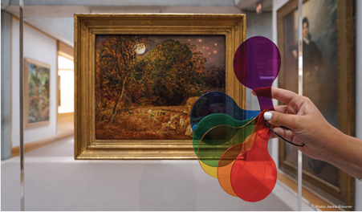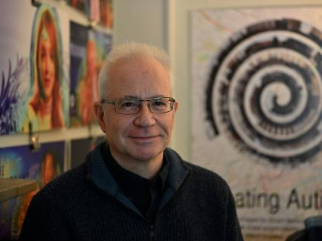
Left to Right: Photo in YCBA by Jackie Gleisner, Portrait of Stuart Neilson

Exhibition Dates: The exhibition runs from October 23 – November 7, 2025
Artist Talk: October 23, 2025 10:00 AM–11:00 AM
Address: NewAlliance Foundation Art Gallery is located at 20 Church Street in New Haven, CT
SUMMARY
In recent years, art museums have increasingly focused on offering experiences of learning, socialization, and self-determination to all visitors, including those who are neurodivergent. As repositories of the visual arts, art museums have great potential to engage neurodivergent visitors through the richness and complexity of their collections. However, museums often unwittingly maintain barriers to access. Tension continues to exist between the traditional role of museums as institutions dedicated to the preservation of collections and their role as spaces in which that collection is available to a diverse public.
As a writer, image-maker, and lecturer in statistics, Stuart Neilson uses his personal experience as an individual with an autism diagnosis to map barriers to access in museums. His keynote will explore how neurodivergent people experience place and space within art museums, as well as how we might advance our understanding of those experiences and address the needs of neurodivergent people in art museums. Using heat-map and stop-motion photography, his photographs visualize the movement within and transitions between spaces in museums, exhibitions, and galleries, and the circulation around them, including the urban streetscape. He is particularly interested in how photography can draw attention to the transitions between spaces and to barriers to access, such as anxiety about entrances, to showcase how “unremarkable” spaces can be difficult for neurodivergent individuals to access.
The goal of empowering neurodivergent people to visit museums on their own terms is a multidisciplinary effort, often relying on input from the fields of medicine, public health, architecture, engineering, design, and museum education. This symposium, "Mind the Gap: Neurodivergence and Art Museums,” brings together voices from these fields to discuss recent developments in the accessibility and ease of experiencing cultural spaces and future possibilities for the inclusion of neurodivergent audiences.

This exhibition is brought to us by First Place-Phoenix, a residential community school in Phoenix, AZ. There will be additional programming at Chapel Haven Schleiffer Center, a residential school in New Haven for adults with social and cognitive disabilities and at the Yale Center for British Art. See more information on the full conference here: https://britishart.yale.edu/exhibitions-programs/neurodivergence-and-art-museums

